The Use of CRISPR Technique to Fight BRCA1 Mutations
Name of Author:
Institution:
Date:

Executive Summary
The BRCA1 are genes largely responsible for the development of breast cancer. Scientists have explored various ways to fight cancer including the reliance on the CRISPR technique to suppress these mutations. The process involves using guide RNA t target nucleotide sequences within the cancerous and alter DNA to make them more cancer resistant. This technology is on a path to perfection but has already provided reliable preliminary findings that the BRCA tumors can be suppressed. Multiple studies have affirmed that use CRISPR technique effectively treats of metastatic cancers, thus offering a promise for success in breast cancer treatment. While there are concerns that the process is unsafe, use of lipid nanoparticle-based delivery has realized safety and effectiveness. Besides, the process is articulate and practical allowing a relatively quick and convenient ways to capture the outcomes. Other concerns have includes high frequency of off-target effects, significant DNA-damage toxicity and immunotoxicity. However, as research intensifies in this areas, more safe and efficient ways would be identified in the use of the technology. Finally, there have been ethical and legal concerns with a section of the research community deeming the technique as unsafe and unnecessary for human subjects. It has however been argued that with proper regulation and adequate data sharing, CRISPR technology has potential to offer real impacts in cancer treatment.

- Introduction
Cancer is a very prevalent and fatal disease accounting for over 10 million deaths globally according to the recent WHO estimates⁸. Among breast cancer, which is common among women, several genes such as Breast Cancer 1 and 2 (BRCA1 and BRCA2) have been linked to increased risk of the disease. For instance, persons with BRCA1 mutations have an approximately 70 percent average lifetime risk of acquiring breast cancer compared to those without these gene mutations⁴. Over the years, scientific studies have attempted to map the causative agents in cancerous cells and develop ways to fight the disease. One of the promising technologies that is currently used is the CRISPR genome editing which has shown potential to reverse the BRCA1 mutations among human subjects⁷.
The use of CRISPR diagnostics technology uses guide RNA (gRNA) to target very particulate nucleotide sequences within the cancerous cells and enables scientists to edit the BRCA1 gene with a possibility of addressing the mutations. In this technique, scientists isolate a nucleotide sequence that only appear in a cancerous cell, then gRNA is synthesized to exactly complement this sequence so that it binds to a genetic sample if it holds the unique signature of a cancerous cell. After the CRISPR-associated enzymes confirm that the guide RNA has the appropriate sequence, the sample nuclei strand is cut off and reprograming is done on the reporter molecules. Ultimately, the editing of the DNA would result in altering the risk of the BRCA on the patients. Therefore, the CRISPR genome editing is an appropriate technology that is swift and convenient even to variations of the BRCA1 genes.

- The Efficiency & Issues in CRISPR Genome Editing
Before offering an in-depth analysis of the pros and cons on the application of the CRISPR tool with respect to breast cancer research, it is vital to have a pictorial representation of its mechanism as shown in figure 1 below;
Figure 1: Pictorial Illustration of CRISPR technology
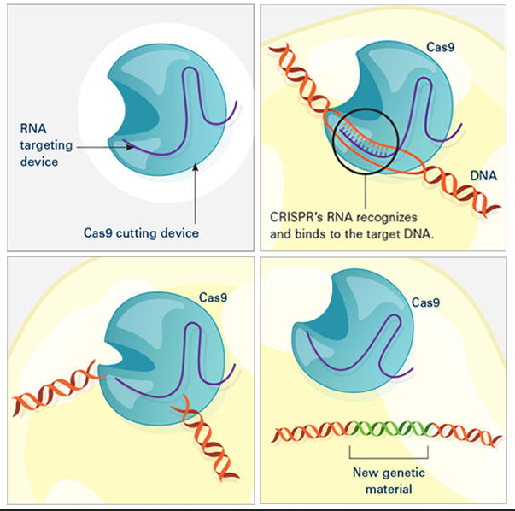

Brief Description: CRISPR comprises of a guide RNA (shown in purple) as well as the Cas enzyme (shown in blue). As the gRNA matches up with the target DNA (as shown in orange), the Cas splits the target DNA forming a new DNA segment (shown in green) which can be added to the DNA string⁹.

  - The Biological Basis of the CRISPR’s Effectiveness
The use of CRISPR genome editing has proven very effective in countering the cancerous growth due to its specificity in enabling the editing of the BRCA1 genes. A team of scientists at the Boston Children’s Hospital and Northeastern University successfully applied this technique to subdue the growth of the cancerous cells in the triple-negative breast cancer¹. Their findings suggested that the application of this technique, in vivo, led to the suppression of the tumors was 77% effective without having toxicity within the cellular tissues. The specificity was attained by use of a noncationic nanolipogel which comprised of nontoxic fatty molecules and hydrogels. They, then targeted the ICAM-1 protein with specific antibodies that effectively directed the CRISPR-containing nanolipogel particles to the cells bearing the cancers. Given that the TNBC cancer is the most aggressive of the breast cancer, their overall findings acknowledged that use of gene editing was impactful in suppressing the growth. The critical part was the use of noncationic nanolipogel which was safer compared to other approaches such as viral mediated delivery or use of the cationic polymers which could result to significant levels of toxicity¹.

In addition to that, the use of gRNA to ensure gene editing as explained in the introductory paragraph is effective in the sense that it is fast and less cost effective. Specifically, the use of paper-based diagnostic tests in which samples applied to detection cards offer color variations offer a simplest way of testing. It is akin to a pregnancy test. It is fairly swift way to offer outcomes within an hour and can be used broadly in hospitals due to their affordability. Besides, during the test, the gRNA can be directed at any sequence of nucleotides and therefore definite areas can be quickly targeted such as mutations in the BRCA1. The use of CRISPR genome editing as a core methodology offers a degree of versatility since the microbes storing the snippets of intruder’s DNA can be able to offer the much needed defense with convenience). By swiftly introducing genetic alterations in the cell lines or targeted organs, the growths are decelerated with minimal harm to the host³. While research into the use of CRISPR tool is ongoing, extant evidence point towards safety, effectiveness and versatility of this method.

  - The Biological Basis of Potential Problems or limitations of the technology
While generally the CRISPR technique is considered safe and efficient, there are a handful of limitations associated by this technology. Firstly, this technique is largely associated with off-target effects as a major limitation. The high frequencies of the off –target effects are evident at the frequency of 50% and above¹¹. While there have been attempts to minimize the off-target effects such as through the use of variants like Cas9n (nickase) along in the gRNA combination, this imitation has not been fully addressed. Essentially, the high frequency of the off-targets means that the efficiency in the specificity of the gene editing is impaired and thus less than perfect results found in addressing the cancerous growths. In addition to that, this technology is limited in a sense that a Protospacer Adjacent Motif (PAM) is usually required near the target site¹¹. It means that there are narrow options in the delivery vehicles used to undertake the gene editing since preferred media such as the SaCas9 are ideal but have longer PAM sequences. While research is ongoing to develop variations that allow precise PAM sequences, current evidence shows that this is a limitation since minimal PAM specificity is vital to get credible results.
Moving on, experiments involving CRISPR-induced edits have revealed significant DNA-damage toxicity as well as immunotoxicity¹¹. The processes that lead to the generation of the double-stranded breaks (DSBs) ought to ensure safety and less toxicity but usually there is a bias. This is to mean that the CRISPR are not entirely safe sometimes leading to low survival rates of the oncogenic cells. As more research intensifies on the most ideal Cas9 orthologs to use to guarantee more safety, a significant number of experiments both in humans and mice have suggested resultant immunogenic toxicity which impairs the credibility of this gene editing technology¹¹. While there has not been any evidence showing environmental risk such as harmful radiations, it is apparent that these limitations make this technology less than optimal for use in fighting breast cancer.

  - CRISPR’s Feasibility and Efficacy
The use of the CRISPR technology has been hailed efficient and feasible to offer compelling outcomes suggesting success in fighting the BRCA1 mutations^{3, 11}. In addition to that, specific experiments in Telaviv and Boston have affirmed that the CRISPR technique is feasible and efficient in treatment of metastatic cancers which offer a promise that the scientific community is on a right path to cancer cure¹². In the Telaviv study, for instance, researchers used the lipid nanoparticle-based delivery system in the technology to target very specific cancerous cells and their use of genetic manipulation yielded outstanding results. In essence, their use of the CRISPR-LNPs injections in the orthotopic glioblastoma promoted up to 70 percent gene editing. In turn, the tumor cell apoptosis was generated that stopped tumor growth by 50 percent while keeping survival rates by less than a third².
While the researchers acknowledged that the efficiency rates are still less than satisfactory, in addition to considerable levels of toxicity to delivery systems, they acknowledges that the results indicated a stable progress to addressing the BRCA1 mutations. In their work, they thoroughly explained why the use of the lipid nanoparticle (LNP) ensured more safety and efficiency than other methods. In addition, the methodologies in the application of the CRISPR technology are well laid out and researchers find it feasible to perform the experiments³. In summary, therefore, the CRISPR technique is efficient and practical to bring about gene disruptions that address the tumor growth among the cancer subjects.
Figure 2: Typical Gene Editing to root out Cancer Cells⁹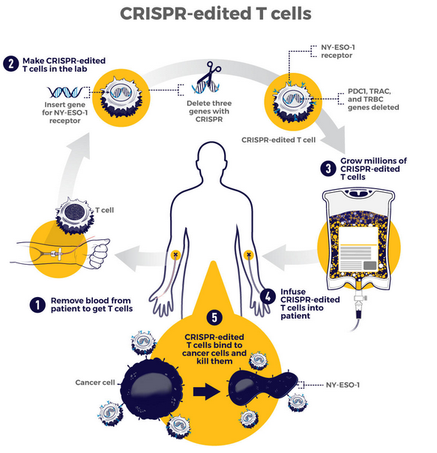
2.4 The Legal and Ethical issues in CRISPR Technology
There are key ethical and legal challenges to the adoption of the CRISPR technique in cancer research and beyond. First, there are concerns about safety and risk of life to the subjects not just to bioethicists and researchers, but also to the general public as well. For instance, the demise of Jesse Gelsinger, a patient in gene therapy trials caused uproar and attracted legislative concerns on how to regulate the technology to keep human subjects safe and healthy⁶. Legally, both the Food and Drug Administration uphold the 1998 policy guidance regarding human somatic cell therapy as well as gene therapy. Other legislations include the Federal Food, Drug, and Cosmetic Act of 1938 and the Public Health Service Act of 1944 to ensure proper regulation of the processes⁶.
Nevertheless, the emphasis is however on how safety information is shared with the public to dispel the misinformation and rumors that gene editing is dangerous. Importantly, researchers need to have accountability and exercise due diligence in their experiments. Additionally, there has been ongoing debate on whether gene therapy should be undertaken on the human subjects with proponents arguing that it should continue to advance clinical and scientific benefits to humanity especially in the area of developing a cure for cancer⁵. While the issues of safety cannot always be guaranteed, as with other clinical trials, it is essential to adopt open-mindedness in advancing this area of research. Many areas of scientific milestones have come with costs including death or incapacitation of the subjects but have yielded great milestones for humanity⁵. While the area of gene editing is still young, there is a promise to achieve more to help humanity in fight for dreadful diseases such as cancers. While ethical concerns are expected, proper legislative environment would guide how research advances and hopefully the world would stand to benefit from its advances in the near future¹⁰. In this regard, the field of CRISPR technology is not new to ethical and legal challenges but researchers need to play within the established legal frameworks and work towards efficiency, affordability and impact to patients.

2.5 Personal Opinion on the CRISPR Technology
In my view, the CRISPR technology is a prosperous field that offer great potential to offer real benefits in fighting cancers and other illnesses. In the practical sense, there is no universal agreement that the CRISPR technology has been proved fully effective in suppressing the BRCA1 mutations. Nonetheless, studies around the world continue to vouch for the effectiveness of this method in the fight for breast cancer and other types of cancer. Following the analysis of facts and evidence explored in this paper, I take a pro- CRISPR approach with an emphasis that it is safe, feasible and efficient method in addressing the BRCA1 mutations. In addition, taking consideration of the ethical and legal concerns, it is essential to take an optimistic side to the debate. While there are costs and sacrifices in any bold scientific inquiry, bioethicists should not be alarmist in branding this technology as unsafe and dangerous to human subjects. Researchers using this technology should be uphold transparency and offer adequate information that would sensitive the general public about issues in the technology. Bottom-line, it is vital to emphasis that research into this field is ongoing and perhaps in a few years, the real impacts of this technology will be mapped out.

References
- Bravekanyawe, C. CRISPR Genome Editing Holds Back Triple-Negative Breast Cancer in Mice. GenNews. https://www.genengnews.com/news/crispr-genome-editing-holds-back-triple-negative-breast-cancer-in-mice/. Updated on August 27, 2019. Accessed 18 December 2020
- Burgstedt, C. CRISPR Technique Effectively Destroys Metastatic Cancer Cells in Living Animal. GenNews. https://www.genengnews.com/news/crispr-technique-effectively-destroys-metastatic-cancer-cells-in-living-animal/. Updated on November 19, 2020. Accessed 18 December 2020
- Chen S, Sun H, Miao K, Deng CX. CRISPR-Cas9: from Genome Editing to Cancer Research. Int J Biol Sci 2016; 12(12):1427-1436. doi:10.7150/ijbs.17421.
- Eldridge, L. BRCA Mutations and Breast Cancer. VeryWellHealth. https://www.verywellhealth.com/brca-mutations-and-breast-cancer-4158206. Updated on September 25, 2019. Accessed 18 December 2020
- Doudna JA, Charpentier E. Genome editing. The new frontier of genome engineering with CRISPR-Cas9. Science. 2014 Nov 28; 346(6213):1258096. Doi: 10.1126/science.1258096.
- Foulkes AL, Soda T, Farrell M, Giusti-Rodríguez P, Lázaro-Muñoz G. Legal and ethical implications of CRISPR applications in psychiatry. North Carol Law Rev. 2019; 97(5):1359-1398.
- Murray, J. How CRISPR Is Fighting Breast Cancer. Synbiobeta. https://synbiobeta.com/how-crispr-is-fighting-breast-cancer/. Updated on September 25, 2018. Accessed 18 December 2020
- Mylavarapu S, Das A and Roy M. Role of BRCA Mutations in the Modulation of Response to Platinum Therapy. Front. Oncol. 2018. 8:16. Doi: 10.3389/fonc.2018.00016
- National Cancer Institute. How CRISPR Is Changing Cancer Research and Treatment. https://www.cancer.gov/news-events/cancer-currents-blog/2020/crispr-cancer-research-treatment. Updated on July 27, 2020. Accessed 18 December 2020
- Sugarman J. Ethics and germ line gene editing. EMBO Rep. 2015; 16(8):879-880. doi:10.15252/embr.201540879
- Uddin F, Rudin CM, Sen T. CRISPR Gene Therapy: Applications, Limitations, and Implications for the Future. Front Oncol. 2020; 10:1387. doi:10.3389/fonc.2020.01387

